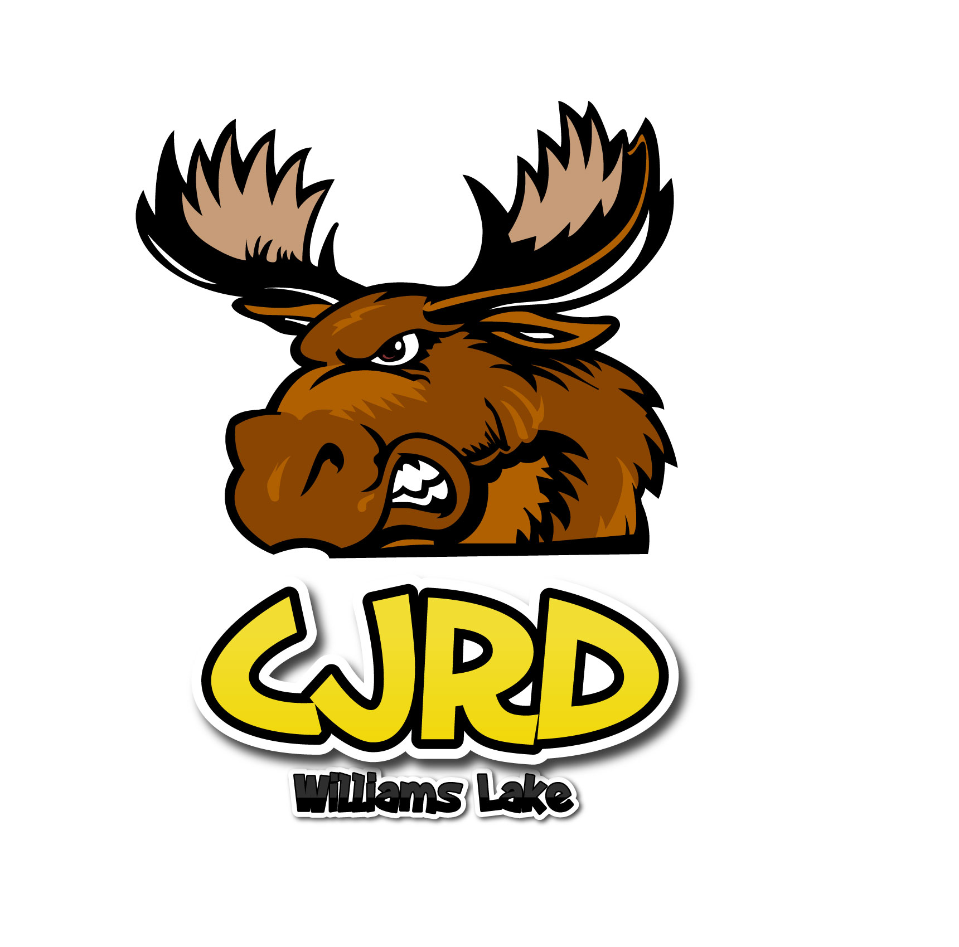
FREEZIN’ for a REASON….Polar Bear Plunge.
FEBRUARY 2nd, 2020 SCOUT ISLAND, WILLIAMS LAKE

WARNING: COLD WATER SWIMMING CAN PRODUCE INJURY AND/OR DEATH

I, ____________________________, have voluntarily elected to participate in the Williams Lake Polar Bear Swim.

I fully understand that this involves jumping or running into the cold water of Williams Lake under February winter weather conditions and that there are health and safety risks associated with this type of activity.
I, therefore, assume all risk of injury and/or death associated with this event and I will not hold the Caribruisers, Williams Lake, Scout Island or other organizers, “Polar Bear Club” or any sponsors liable for any circumstance related to this event.
I hereby confirm that I am in good physical condition and do not suffer from any disabilities or physical conditions that places me at risk or otherwise should prohibit my participation in the Williams Lake, Scout Island Polar Bear Swim.
Furthermore, in consideration of my participation in this program, I myself, my heirs and assigns, release the Caribruisers Roller Derby, their sponsors and any volunteers, from any and all claims, actions, demands, expenses liabilities (including reasonable attorney's fees) and negligence made or brought by myself or said minor or by anyone on behalf of said minor, as a result of participation in the Event.
I, for myself or on behalf of said minor, further agree not to sue the any of the officers, agents, affiliates, employees, contractors, or volunteers, as a result of any injury, paralysis or death that might be suffered in connection with participation in the Event.

I hereby affirm that I fully understand the preceding paragraphs and volunteer to participate at my own risk.

Participant: _________________________________

Witness: ___________________________________
(print names)

Signature: __________________________________
Signature: __________________________________

Date: ______________________

Signature of Parent or Guardian: ____________________________________________________
(Required for participants under the age of 18)

*Please present this along with your forms to the REGISTRATION Table to get your Stamp and # for Jump.

